|  |
| --- |
| THE RESTAURANT MANAGEMENT SYSTEM |
|  |
|  |
|  |

**CONTENT**

Abstract …………………………………………………………………… i

Keywords …………………………………………………………………… ii

Acknowledgement …………………………………………………………………… iii

List of Figure …………………………………………………………………… iv

**Chapter 1: Introduction …………………………………………………… 1**

1.1 Objective …………………………………………………… 1

1.2 Motivation …………………………………………………… 2

1.3 Overview …………………………………………………… 3

**Chapter 2: Literature Overview …………………………………………………… 4**

**Chapter 3: Methodology …………………………… 6**

3.1 Software Tool Specification ……………………….. 6

3.2 Block Diagram ……………………….. 7

3.3 Flow Chart ………………………. 8

3.4 Login ………………………. 9

3.5 Item List ………………………. 9

3.6 Cake ………………………. 10

3.7 Drinks ………………………. 11

3.8 Fried ………………………. 11

3.9 Pizza ………………………. 12

3.10 Soup ………………………. 13

3.11 Order ………………………. 14

3.12 Receipt ………………………. 15

**Chapter 4: Output of project …………………………………………………… 17**

4.1 Login …………………………………………………… 17

4.2 Item List …………………………………………………… 20

4.3 Cake …………………………………………………… 22

4.4 Drinks …………………………………………………… 24

4.5 Fried …………………………………………………… 27

4.6 Pizza …………………………………………………… 29

4.7 Soup …………………………………………………… 32

4.8 Customer Data …………………………………………………… 34

4.9 Order …………………………………………………… 36

4.10 Payment …………………………………………………… 38

4.11 Receipt …………………………………………………… 40

**Chapter 5: Conclusion …………………………………………………… 41**

**References …………………………………………………………………………… 43**

**Appendix ……………………………………………………………………………. 44**

**Abstract:**

The project, “Restaurant Management System” has been developed to maintain the entire management system of a restaurant on the software based environment. This project has been done using “Java” programming language. The program will provide a user to access the system through a common username and password. Then the user will be able to use it for various purposes such as browsing different categories of recipes based on food items including its updated price list and images. Moreover, online order in the restaurant is also offered to the user to make an order. Hence, the user must provide his/her name as well as mentioning the type of order. Therefore the system will automatically create a billing and a payment method with two different type of payment category, either cash or online card. Finally, a printed copy of receipt containing the ordered food menu with its total price will also be provided by the system after paying the bill in a proper way. The system will ensure the user with advanced technology which can provide a better look and feel. However, this project facilitates the entire restaurant management system in the basis on digital advantages.

**Keywords:** Login, Item list, Cake, Drinks, Fried, Pizza, Soup, Menu, Theme, Order, Exit

**Acknowledgement**

The idea of this project, “Restaurant Management System” has been established having an overview of an entire management system of a restaurant. This system has been developed by using “Swing in Java”. This feature has been learnt in the books on “Java Programming Language” of different writers. We have been benefited by this sort of programming language books and are now mentioning some of them.

“Java The Complete Reference” (8th edition) by Herbert Schildt.

“Head First Java” (2nd edition) by Kathy Sierra and Bert Bates.

We have also found different websites browsing the internet and collected numerous information regarding this project. Most of them provided many useful tutorials based on GUI in Java.

[www.docs.oracle.com](http://www.docs.oracle.com)

[www.stackoverflow.com](http://www.stackoverflow.com)

[www.tutorialspoint.com](http://www.tutorialspoint.com)

[www.java2s.com](http://www.java2s.com)

Many authors in “Youtube” are also credited who provided their educative and informative tutorials as an open source. Some of them are listed below:

“Introduction to Java Programming” by Udacity.

“Netbeans Java GUI” by Programming Knowledge.

“Java Video Tutorial” by Derek Banas.

“Java Swing Tutorial Netbeans” by Asiful Haque.

Above all, we, the student of dept. “ICT” in the university “BUP” are cordially grateful to our respected and beloved “Computer Programming” course teacher, **Dr. Mohammad Abu Yousuf** sir, Jahangirnagar University.

**List of Figure**

Figure List Page No.

3.2 Block Diagram 7

3.3 Flow Chart 8

4.1.1 Login window at default theme 17

4.1.2 Showing password and username 18

4.1.3 Hiding password and displaying username 18

4.1.4 Reset the Login Window 19

4.1.5 Invalid username or password 19

4.1.6 Exit option in Login Window 20

4.2.1 Item List frame as default theme 20

4.2.2 Item List with different theme 21

4.2.3 Item List with different food category 21

4.3.1 Cake with default theme 22

4.3.2 Different cake list with image1 22

4.3.3 Different cake list with image2 23

4.3.4 Different cake list with image3 23

4.3.5 Exit in Cake frame 24

4.4.1 Drinks frame with default theme 24

4.4.2 Different drinks with image1 25

4.4.3 Different drinks with image2 25

4.4.4 Different drinks with image3 26

4.4.5 Exit in drinks frame 26

4.5.1 Fried with default theme 27

4.5.2 Different fried with image1 27

4.5.3 Different fried with image2 28

4.5.4 Different fried with image3 28

4.5.5 Exit in fried frame 29

4.6.1 Pizza with default theme 29

4.6.2 Different pizza with image1 30

4.6.3 Different pizza with image2 30

4.6.4 Different pizza with image3 31

4.6.5 Exit in pizza frame 31

4.7.1 Soup with default theme 32

4.7.2 Different soup with image1 32

4.7.3 Different soup with image2 33

4.7.4 Different soup with image3 33

4.7.5 Exit in soup frame 34

4.8.1 Customer Data with default theme 34

4.8.2 Customer Data with invalid input 35

4.8.3 Customer Data with valid input 35

4.8.4 Customer Data with another valid input 36

4.9.1 Order with default theme 36

4.9.2 Proper selection of food item 37

4.9.3 Particular order can be reset 37

4.9.4 Performing the order calculation 38

4.10.1 Payment with default theme 38

4.10.2 Invalid amount 39

4.10.3 A valid payment method 39

4.11.1 Copy of receipt 40

4.11.2 Receipt with order and bill 40

**CHAPTER 1**

**INTRODUCTION**

**1.1 Objective:**

The project, **“Restaurant Management System”** deals with the entire management, ordering, billing & payment method of a restaurant in the light of software environment. This project will help both a restaurant owner and restaurant user to maintain the entire management system of a restaurant in a systematic way. This system can also provide the entire restaurant management with proper security and privacy.

Moreover, the user can browse the food menu on the basis of different categories of food type such as cake, drinks, fried, pizza, soup etc. The food list also provides an updated price list as well as particular images of each food item. So, the user can easily check out each food’s price and uploaded image. Therefore, in the order menu the user can make an order at his/her own choice. In order to make a valid order, the system must check the valid information of a customer which will be given by the user.

Undoubtedly, it is very important to make sure whether a user has made a valid order by giving customer name and type of order such as table order or a home delivery order. After making a valid order, the user will be able to have a printed copy of its receipt. But before getting the receipt, user must pay for the assigned bill through cash or electronic card. Above all, this project has been developed to perform the entire restaurant management system on a software based environment.

**1.2 Motivation:**

The aim of this project is to create a software based field in the restaurant management system. Bangladesh, a developing country is progressing day by day with the enlightened field of ICT. With the mission of “VISION 2021” the official – unofficial tasks are performed with the light of ICT. So, in the field of Information & Communication Technology, it is now very important to promote a software based system in every aspect of our daily to daily life.

In our country, there are a lot of restaurant as well as cafe. People visit them regularly and make an order instantly in the restaurant or for home delivery. Many of the highly expensive and gorgeous restaurants have their own software to deal with the customer. But, most of the restaurants and cafes have no secured software to manage their food items with proper images. Besides, people still now have a menu in their hand with no image of that particular item and make an order to the restaurant boy by words. Somewhere, the customer are provided with a receipt that is made manually by the restaurant account section. Even, most of the restaurants have no ATM or online card reader machine. People have to pay their bill in cash. Most of the cases, they have no other choice rather paying the bill in cash.

In this old tradition of ordering the food menu, creating a hand written bill and paying the bill in cash, there might happen any kind of unexpected situation. The customers may complain the restaurant for serving poor quality of food item. Sometimes they are not confirmed what they are ordering for because images of food items are not always available in the menu list. So, the customers are not assured of the quality of food items that they are being served. Moreover, there could be a good chance to make a mistake regarding the hand written bill. Further, a limited opportunity of paying the bill may also create any unsatisfactory scenario to the customer. However, the online system of browsing as well as ordering food menu, the appropriate billing system with a printed copy of receipt and paying the bill both in cash and online card are not available to the every restaurant and cafe in Bangladesh.

**1.3 Overview:**

In this modern era, in order to keep pace with the digital world, people feel more comfortable using the software in computer or apps in the smartphone or online websites browsing the internet. This project has been modeled to make the system user friendly. The customer or the user will find this system more useful and pleasant. It also provides a secured payment both in cash and online card which may build a better professional understanding between the clients and restaurant management authority.

Now-a-days, we cannot go a single day without the touch of digital and electronic system. People feel better using both online and offline version of software. Prior to their choice, the restaurant authority can manage this system in the restaurant or cafe. People can make an easy order sitting before the table or using the online website of the restaurant even staying at home. Therefore, the restaurant authority will get notification from the user and ensure the bill either in cash or in card that will be paid by the customer or the user.

**CHAPTER 2**

**LITERATURE OVERVIEW**

**2.1 Related Work:**

In order to review the concept of this project, there are a lot of projects related to “Restaurant Management System” have already done and still now are being developed by various author. Many of these similar projects are uploaded in different websites with their project report as well as the design with the screenshots. Some of them are mentioned in the following:

* “Cafe Management System” by DJ Oamen.
* “Restaurant Management System” by Waleed Adel.
* “Restaurant Management System (RMS)” by the student of Christ University, India.
* “OpenBooth: Restaurant Order Management” by David Adam.
* “Java Restaurant Management System” by Ronald McArthur.
* “OMS: Order Management System” by Juan Carlos Alvarez.
* “Hotel Ordering System” by Rizwan Khatik.
* “Food Ordering” by Pitre.

We have been encouraged and inspired viewing these projects. Therefore, we have implemented our own design and model with some additional features and unique look and feel to this system.

**CHAPTER 3**

**METHODOLOGY**

**3.1 Software Tool Specification:**

**“The Restaurant Management System”** has been developed by using ‘Java Programming Language’. The software tools that have been used in this system:

* Programming Language : Java
* IDE : Netbeans 8.1
* Swing GUI : JFrame Form
* Operating System : Windows 7 (x64)

There are twelve JFrame have been used to complete the entire project in Java. Each JFrame has its own title regarding to its operation. Every JFrame contains a null layout. The frame size and border is definite so that the user may have a greater view while using the system.

**3.2 Block Diagram:**

Login

Item List

Drinks

Cake

Fried

Pizza

Soup

**3.3 Flow Chart**

Receipt

Payment

Order

Customer Data

Exit

Order

**3.4 Login:**

This system starts with a login frame. In this frame, a JPanel, a JLabel and a JMenuBar have been used on the basic JFrame. Hence, the JPanel contains three different JLabel referred as (i) “RESTAURANT MANAGEMENT SYSTEM”, (ii) “User Name:”, (iii) “Password:” and two different JTextField for getting input from the user as well as three different JButton known as (i) “LOGIN”, (ii) “RESET”, (iii) “EXIT”.

Here, the system will get input of username and password from the user. This feature has been added in order to ensure the privacy and security of the system. As input, the system will check both username and password followed by the user to access the next frame referred as “Item List”. In this project, a common username and password has been set for the user.

User Name: “User”

Password: “0pass1”

In case of giving an invalid username or password, the system will provide the user with an error message showing “Invalid User or Password”. In addition to “RESET” button, the input field can also be reset. Moreover, in the menu bar of this frame, there are two menu lists: Menu, Theme. Seven different themes have been used in the “Theme” menu list. By clicking “EXIT” button or pressing Alt+F4 or selecting “Exit” from the menu bar, it performs the system to an instant exit. Only mentioning the exact username and password, the user can access the next frame.

**3.5 Item List:**

The frame “Item List” contains the basic food category of a restaurant. This frame has been modeled by using a JPanel and a JMenuBar on the basic JFrame. The JMenuBar contains two different menu list known as (i) Menu and (ii) Theme. And the JPanel consists of a JLabel and six different JButton in addition to two another JButton referred as (i) “Back” and (ii) “EXIT”. The six JButton is connected to the six different new frames, respectively (i) “CAKE”, (ii) “DRINKS”, (iii) “FRIED”, (iv) “PIZZA”, (v) “SOUP” and (vi) “Order”.

Through the menu bar “Menu”, the user can instantly access any of the listed frames. Key strokes have also been added to using the system with more comfortable and friendly. Another menu bar “Theme” provides seven different themes which can be set as a background of each frame.

Clicking the JButton “CAKE” or pressing Ctrl+C, the user can access a new frame, “Cake”. Similarly, clicking the JButton “DRINKS” or pressing Ctrl+D, user may access the frame, “Drinks”; clicking the JButton “FRIED” or pressing Ctrl+F, user can access the frame, “Fried”; clicking the JButton “PIZZA” or pressing Ctrl+P, user may access the frame, “Pizza” and by clicking the JButton “SOUP” or pressing Ctrl+S, the user can access the frame, “Soup”. The remaining JButton “Order” creates a field for storing necessary data given by the user. So, in order to access the “Order” frame, user may either click on the JButton “ORDER” or press Ctrl+O.

The JButton “Back” gets the user back to the main frame, “Login” and the JButton “EXIT’ performs with a caution message confirming either ‘Yes’ or ‘No’. The system will immediately get exit if ‘Yes’ is pressed, otherwise it won’t.

**3.6 Cake:**

If the user selects the JButton “CAKE” then a new frame, “Cake” will appear. As a part this frame’s model, a JPanel and a JMenuBar have been set on its basic JFrame. As usual, the JMenuBar contains “Menu” and “Theme” list which have already been mentioned. The JPanel consists of four different JLabel referred as (i) “CAKE”, (ii) “Item List”, (iii) “Rate” and (iv) “Image”. Further, a JLabel has been added to show the image of each particular cake item. Moreover, nine different JLabel has also been set for showing the specific unit price of each cake item in BDT currency.

In this project, nine cake items have been listed in the “Cake” frame with its unit price as well as image. User may select any of this cake items to see its particular image. To complete this task, nine different JButton was set. By clicking each JButton, different image of different cake item will appear. Images can ensure the user to the respective item that he/she has selected.

In the bottom right corner, two different JButton have been used known as (i) “MENU” and (ii) “EXIT”. The “MENU” button provides the user to get back to the “Item List” frame. By clicking “EXIT” button or pressing Alt+F4 or selecting “Exit” from the menu bar, it performs the system to an instant exit.

**3.7 Drinks:**

When a user clicks on the JButton “DRINKS” at the frame “Item List” then a new frame, “Drinks” will appear. As a design of this frame, a JPanel and a JMenuBar have been included on its basic JFrame. As usual, the JMenuBar contains “Menu” and “Theme” list which have already been mentioned. The JPanel consists of four different JLabel referred as (i) “DRINKS”, (ii) “Item List”, (iii) “Rate” and (iv) “Image”. Further, a JLabel has been added to show the image of each particular drinks item. Moreover, nine different JLabel has also been set for showing the specific unit price of each drinks item in BDT currency.

In this project, nine drinks items have been listed in the “Drinks” frame with its unit price as well as image. User may select any of these items to see its particular image. To complete this task, nine different JButton was set. By clicking each JButton, different image of different drinks item will appear. Images can ensure the user to the respective item that he/she has selected.

In the bottom right corner, two different JButton have been used known as (i) “MENU” and (ii) “EXIT”. The “MENU” button provides the user to get back to the “Item List” frame. By clicking “EXIT” button or pressing Alt+F4 or selecting “Exit” from the menu bar, it performs the system to an instant exit.

**3.8 Fried:**

If the user selects the JButton “FRIED” then a new frame, “Fried” will appear. As a part this frame’s model, a JPanel and a JMenuBar have been set on its basic JFrame. As usual, the JMenuBar contains “Menu” and “Theme” list which have already been mentioned. The JPanel consists of four different JLabel referred as (i) “FRIED”, (ii) “Item List”, (iii) “Rate” and (iv) “Image”. Further, a JLabel has been added to show the image of each particular fried item. Moreover, nine different JLabel has also been set for showing the specific unit price of each fried item in BDT currency.

In this project, nine fried items have been listed in the “Fried” frame with its unit price as well as image. User may select any of these fried items to see its particular image. To complete this task, nine different JButton was set. By clicking each JButton, different image of different fried item will appear. Images can ensure the user to the respective item that he/she has selected.

In the bottom right corner, two different JButton have been used known as (i) “MENU” and (ii) “EXIT”. The “MENU” button provides the user to get back to the “Item List” frame. By clicking “EXIT” button or pressing Alt+F4 or selecting “Exit” from the menu bar, it performs the system to an instant exit.

**3.9 Pizza:**

In case of selecting the JButton “PIZZA” in the “Item List” frame, a new frame will appear before the screen named “Pizza”. A JPanel and a JMenuBar have been set on its basic JFrame. Similarly, the JMenuBar contains two different menu list, (i) “Menu” and (ii) “Theme”. The operation of this JMenuBar has been mentioned in the earlier. The JPanel consists of four different JLabel known as (i) “PIZZA”, (ii) “Item List”, (iii) “Rate” and (iv) “Image”. Further, a JLabel has been added to show the image of each particular pizza item. Moreover, nine different JLabel has also been used for showing the unit price of each fried item particularly in BDT currency.

Nine different JButton containing nine different pizza lists performs to show the respective image of pizza when they are selected by the user. At the bottom, two new JButton (i) “MENU” and (ii) “EXIT” has been added to perform different operation. Clicking the “MENU” button, it returns to the “Item List” frame and the JButton “EXIT’ performs with a caution message confirming either ‘Yes’ or ‘No’. The system will immediately get exit if ‘Yes’ is pressed, otherwise it won’t.

**3.10 Soup:**

In order to visit the “Soup” frame, the user needs to click on the JButton “SOUP” at the “Item List” frame. The basic JFrame of “Soup” consists of a JPanel and a JMenuBar. As mentioned earlier, the JMenuBar contains two different menu list, known as (i) “Menu” and (ii) “Theme”. The JPanel contains four different JLabel referred as (i) “SOUP”, (ii) “Item List”, (iii) “Rate” and (iv) “Image”. Besides, a JLabel has also been added to show the image of each particular item.

Again, nine different JLabel has been set for showing the updated unit price of each soup item in BDT currency. Moreover, nine soup items have been listed into nine different JButton. Different image of different soup item are shown by clicking the respective JButton. The JButton “MENU” gets the user back to the frame, “Item List”. The JButton “EXIT” performs an immediate exit of the system by confirming ‘Yes’ option.

**3.11 Order:**

If the user wishes to make an order to the system, then he/she should have clicked on “ORDER” at the frame “Item List” or pressing Ctrl+O. Making an order, two different frames are performed. In the following passage, this is going to be discussed elaborately.

**3.11.1 Customer Data:**

Before entering the “Order” frame, the user must fill the entry form which is referred as “CUSTOMER DATA”. The basic JFrame of “Customer Data” consists of seven JLabel, five JTextField, two JRadioButton and three JButton. The JLabels are (i) “CUSTOMER DETAILS”, (ii) “Name”, (iii) “Address”, (iv) “Mobile NO” and rest of the three contains three red stars which mean the field requires to be filled by the user.

The two JRadioButton are (i) “Table Order” and (ii) “Home Delivery”. This two option can’t be selected at a time. The user may select either “Table Order” or “Home Delivery”.

The five JTextField have been used for inserting data by the user. The JLabel which contains red star, must be filled by the user. Otherwise the system will provide an error message due to empty field of information.

The three JButton are (i) “Order”, (ii) “Reset” and (iii) “Exit”. Only after providing the required information of a customer, the system will proceed to the next frame, “ORDER” to make the order. So before entering into the next frame, the user must fill the field of ‘Name’ and either ‘Table Order’ or ‘Home Delivery’. If the user wants to reset the given data, it is required to click the button “Reset”. The “Exit” button provides the user to make an exit of the system.

**3.11.2 Order:**

The frame “ORDER” is the most extensive part of the system because of its extreme calculation and stylish design. A JMenuBar and a base JPanel were formed on its basic JFrame. As mentioned earlier, the JMenuBar consists of “Menu” and “Theme”. The base JPanel conatins six different JPanel as well as five JButton. The first five JPanels contain ten different JCheckBox, thirteen JLabel and nine JTextField.

The first JPanel is for ordering ‘Cake’ items. In this module, the nine JCheckBox is used for showing and selecting the cake items one by one and the last one is used to reset the specific order. However, three JLabel is used to show the basic category of food item name, rate and unit. The remaining nine JLabel is used for showing each item’s price and the last one JLabel is used to show the particular total cost of ‘Cake’ item.

Similarly, the rest of the four JPanels have been used for ordering the remaining four food items, respectively ‘Drinks’, ‘Fried’, ‘Pizza’ and ‘Soup’. All these food items are enabled to take an order from the user as like as the ‘Cake’ item performs.

The last JPanel contains seventeen JLabel to show the current date and time, table no or delivery charge (depends on user choice), subtotal, vat including 2.5% and grand total.

The previously described five JButton are (i) “SUM”, (ii) “RESET”, (iii) “RECEIPT”, (iv) “MENU” and (v) “EXIT”.

The button “SUM” is for performing the entire calculation regarding the current date and time, customer name, order type as well as subtotal, vat and grand total. By clicking “RESET” button, the entire given order will be reset. The button “RECEIPT” will provide the user with a printed copy of receipt after paying the bill. The button “MENU” gets the user back to the frame, “Item List”. And the button “EXIT” operates to exit the system instantly.

**3.12 Receipt:**

After making a successful order, the user will be able to have a printed copy of receipt. But before getting the receipt, the user must pay for the bill.

**3.12.1 Payment:**

By clicking the button “RECEIPT” at the “Order” frame, the system will bring the user to a new frame, “Payment”. In this frame, a JMenuBar and a JPanel have been set on its basic JFrame. As usual, the JMenuBar contains “Menu” and “Theme”. The JPanel consists of three different JLabel, six JRadioButton, two JTextField and a JButton apparently.

The first JLabel contains the title “PAYMENT” and rest of the two is for showing “BDT”. The user may select a single JRadioButton, either “Cash” or “Card”. If ‘Card’ is selected, then the user should select any of the four online cards (i) “Credit Card”, (ii) “Debit Card”, (iii) “Master Card” or (iv) “Visa Card”.

The user must insert the exact bill in number in the JTextField. The system will show an error message, if the user keeps the JTextField empty or fills with less amount of bill. Only after paying the bill in a proper method, the user will be able to have the receipt through clicking the JButton “OK”.

**3.12.2 Receipt:**

Finally, the user will be able to have the receipt which is a printed copy of what he/she ordered.

In the design of receipt, a JLabel and a JTextArea are set on its basic JFrame. The JLabel is used to show the word “RECEIPT”. The JTextArea contains the printed copy the receipt. In the receipt date and time, customer name, table no or home delivery address and the selected food items are printed sequentially. The receipt will end displaying a formal greeting to the user ‘Thank You!’

**CHAPTER 4**

**OUTPUT OF THE PROJECT**

**4.1 Login:**  The system starts with a login window. It verifies the Username and password given by the user. Different theme is also used in this frame to make it more delightful and user friendly.

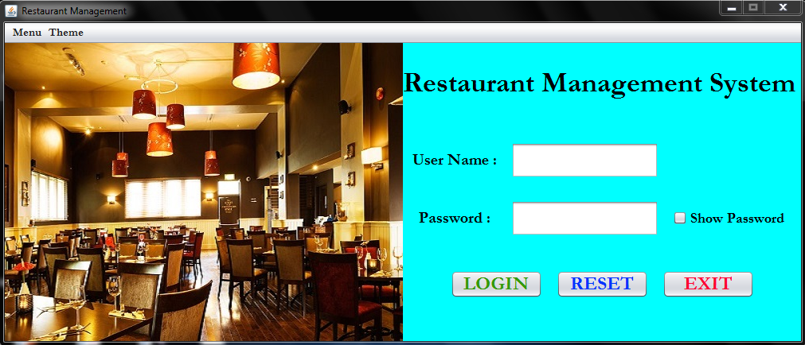

**Fig. 4.1.1 Login window at default theme**

The username is always seen as usual. But the password is hidden as default. By clicking “Show Password”, the password which is provided by a user could be seen. The default username and password have been shown in the following picture.

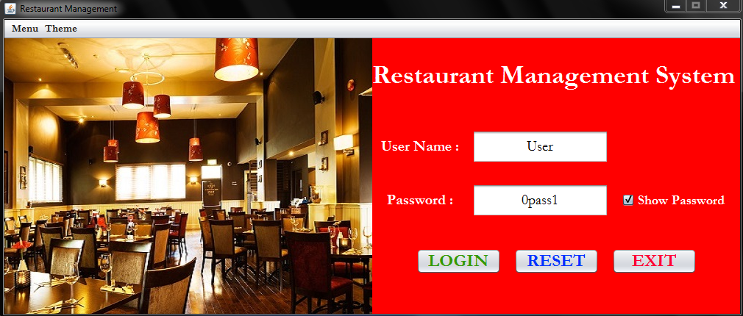

**Fig. 4.1.2 Showing password and username**

If the user wants to hide the given password, it is possible to hide the password by making the “Show Password” option unmarked.

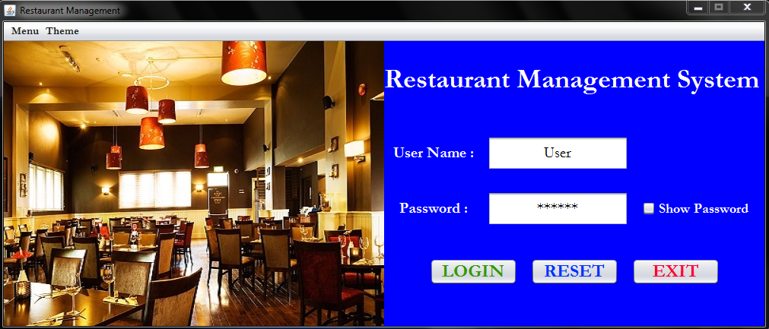

**Fig. 4.1.3 Hiding password and displaying username**

The field of username and password could be reset, if the user wants it to do so. Hence, the given data provided by the user will be reset.

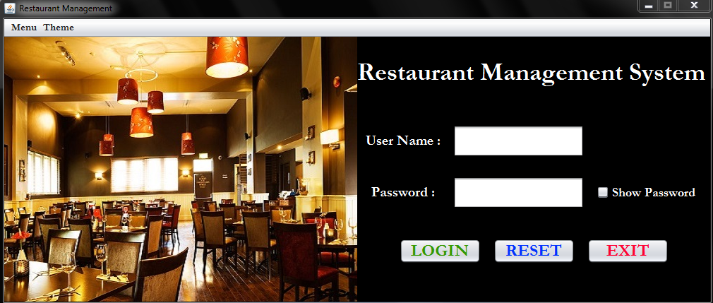

**Fig 4.1.4 Reset the Login Window**

The system will automatically provide an Error message while the user gives an invalid input. This Error message will be displayed when the username or password or both are incorrect or having an empty field.

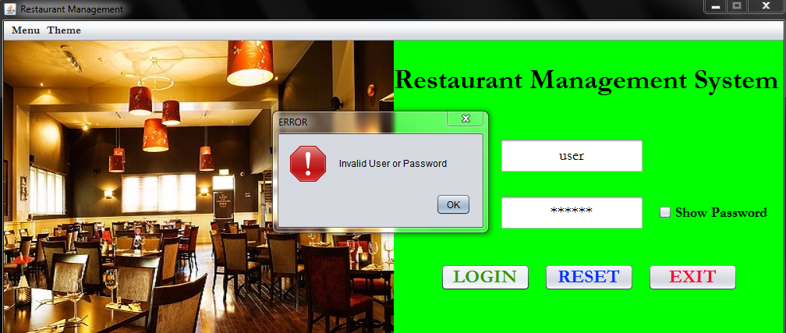

**Fig. 4.1.5 Invalid username or password**

The button “EXIT” provides the user to exit the frame instantly. If “Yes” option is clicked by the user, the system will be exit otherwise not.

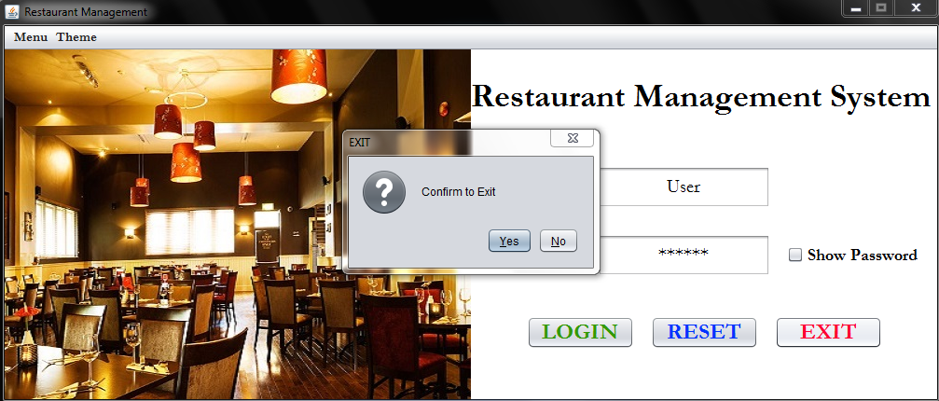

**Fig 4.1.6 Exit option in Login Window**

**4.2 Item List:** When the username and password will be filled with correct format, then the user can login into the next frame referred as “Item List”.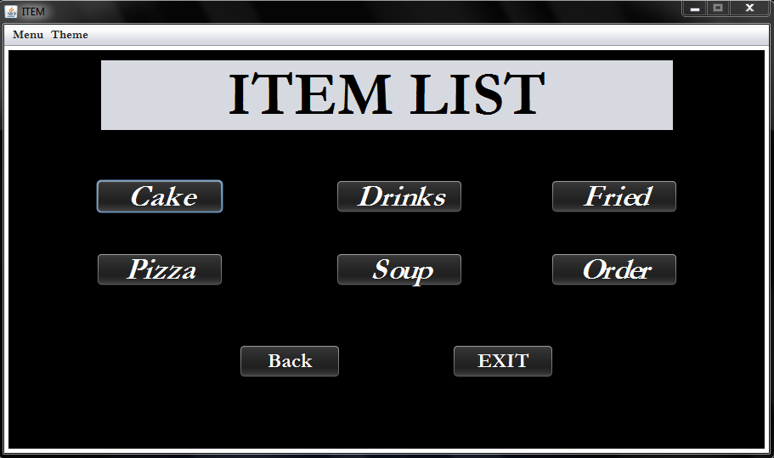

**Fig. 4.2.1 Item List frame as default theme**

The “Item List” frame provides a user to browse the basic category of various food item that has been shown in the following figure.

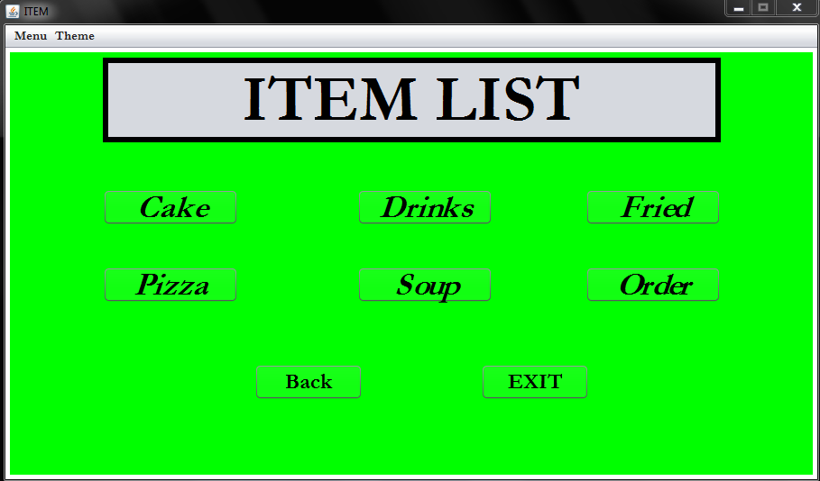

**Fig. 4.2.2 Item List with different theme**

Different theme can be applied from the menu bar “Theme”.

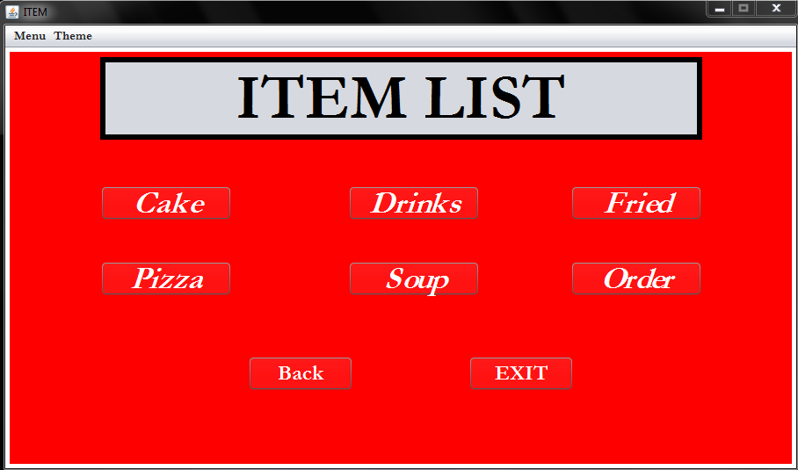

**Fig. 4.2.3 Item List with different food category**

**4.3 Cake:** After clicking “Cake” button, the following frame will appear with this default theme.

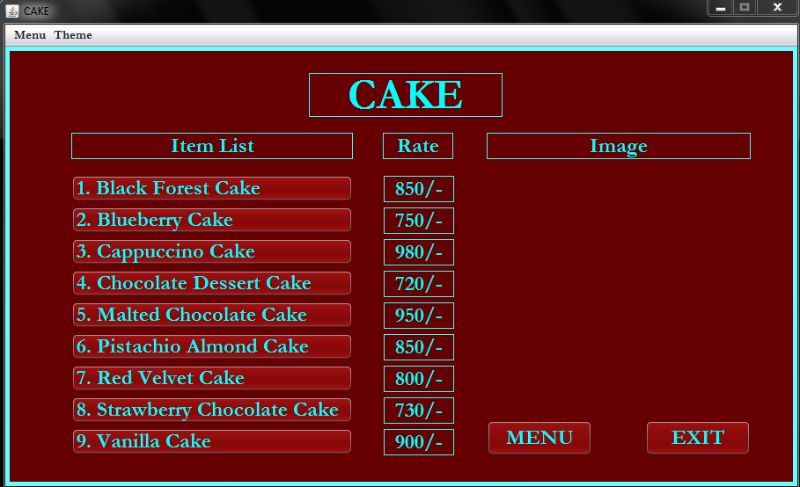

**Fig. 4.3.1 Cake with default theme**

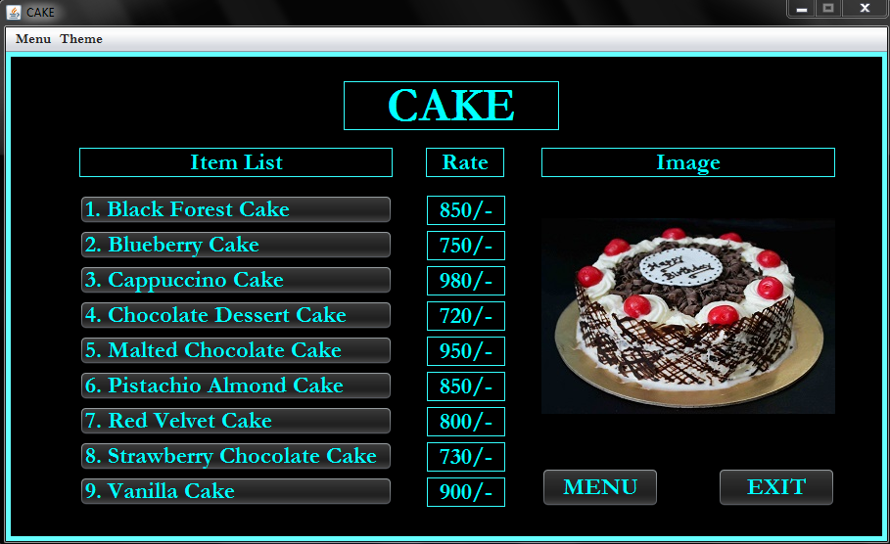

**Fig. 4.3.2 Different cake list with image1**

“Theme” has been set for changing the background color.

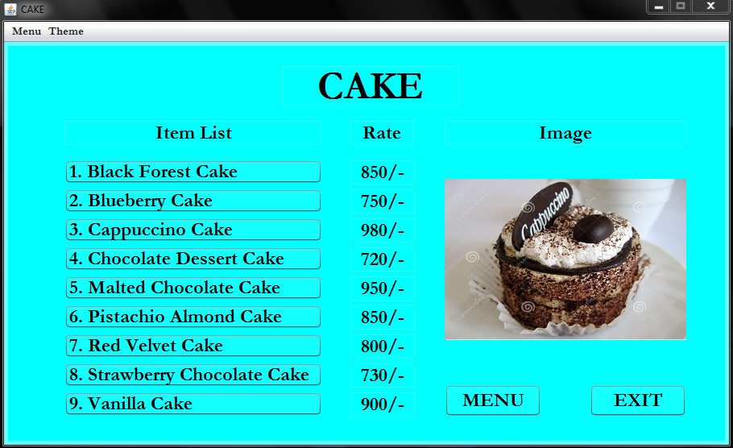

**Fig. 4.3.3 Different cake list with image2**

While clicking any of this buttons, image will be appeared instantly.

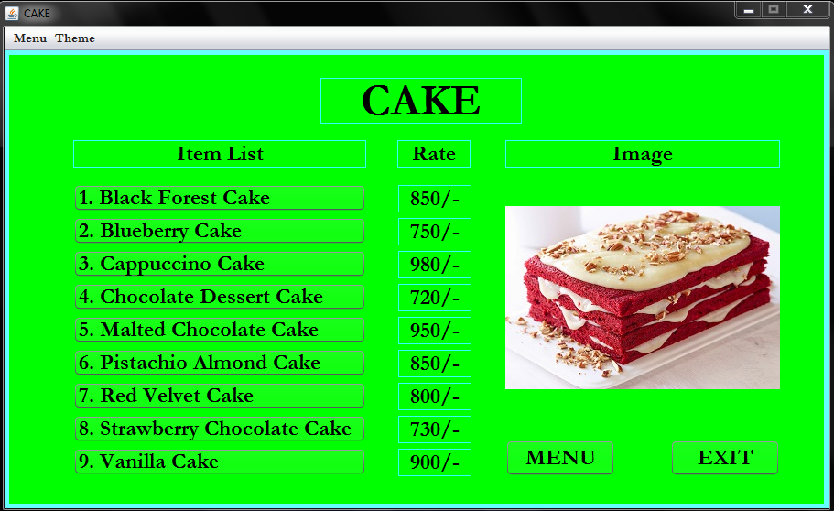

**Fig. 4.3.4 Different Cake list with image3**

Clicking the “EXIT” button, the user can choose to exit the frame.

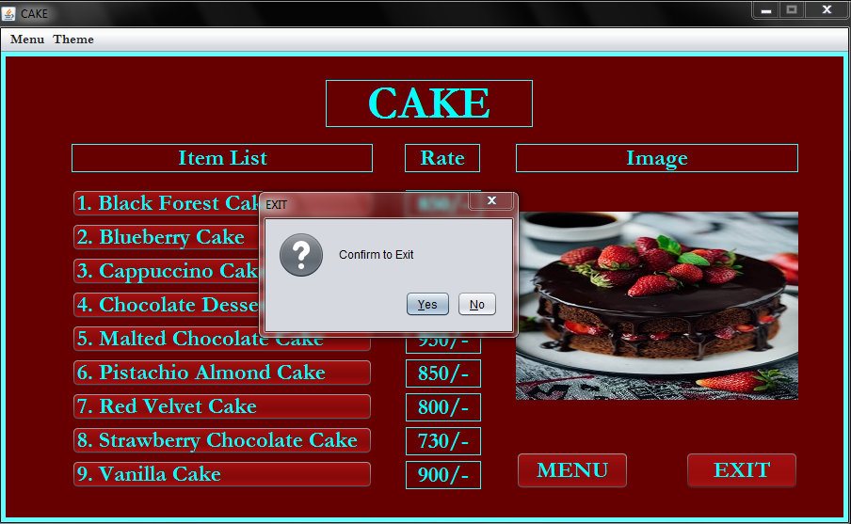

**Fig. 4.3.5 Exit in Cake frame**

**4.4 Drinks:** By clicking the “Drinks” button in “Item List”, this frame will appear with the following default theme.

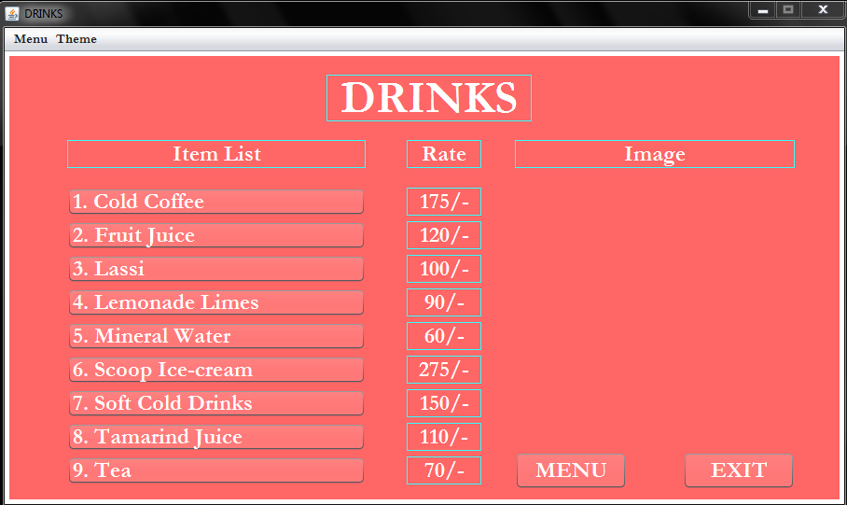

**Fig. 4.4.1 Drinks frame with default theme**

For example, if the user clicks ‘Lemonade Lassi’, the following image will be shown.

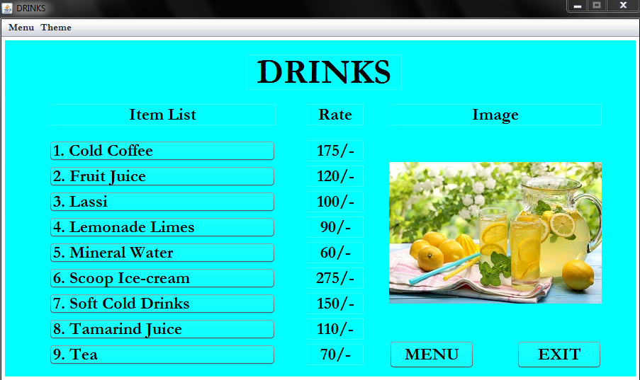

**Fig. 4.4.2 Different drinks with image1**

Another instance clicking ‘Soft Cold Drinks’.

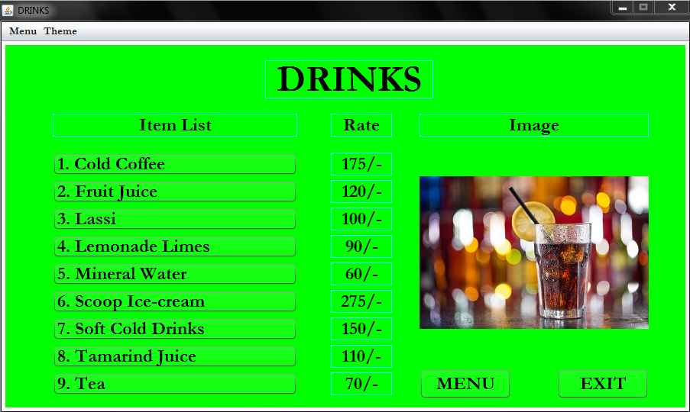

**Fig. 4.4.3 Different drinks with image2**

From the menu list “Theme”, the user can change the background color as shown in this figure.

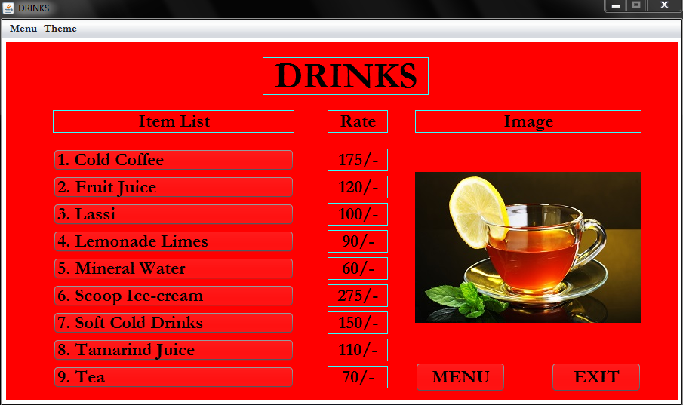

**Fig. 4.4.4 Different drinks with image3**

Clicking the “EXIT” button, the user can choose to exit the frame.

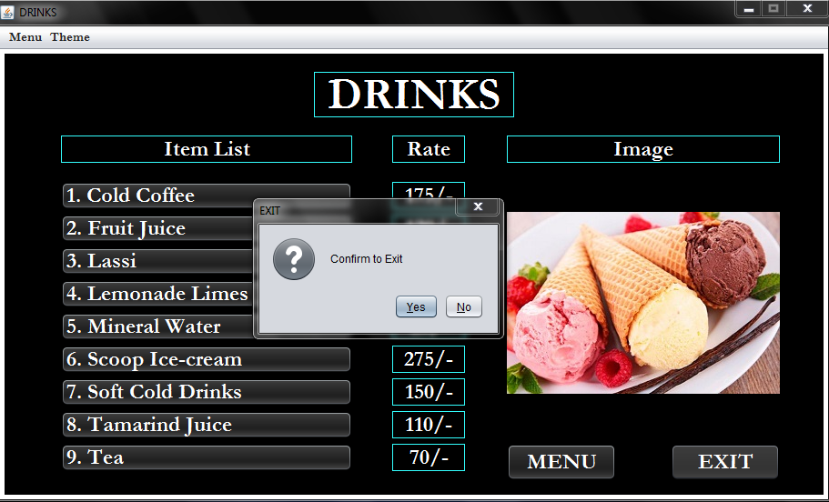

**Fig. 4.4.5 Exit in drinks frame**

**4.5 Fried:** After clicking “Fried” button, the following frame will appear.

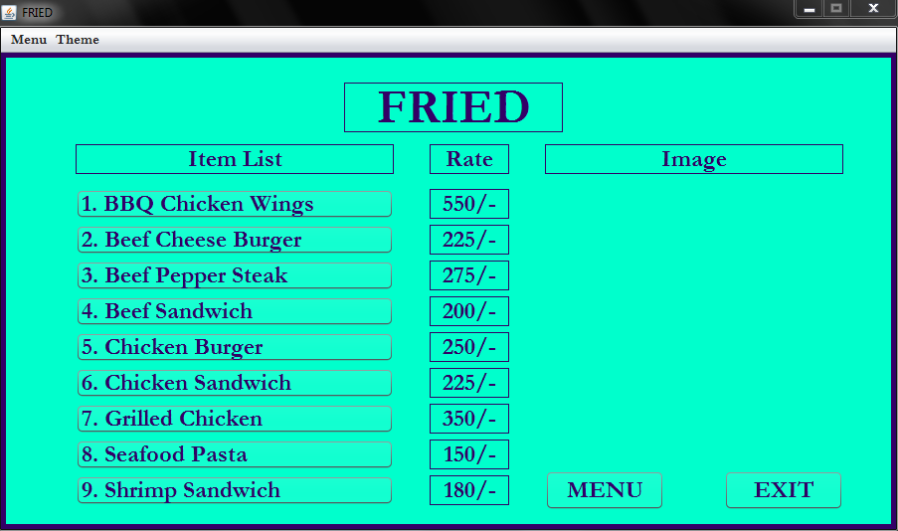

**Fig. 4.5.1 Fried with default theme**

Clicking ‘BBQ Chicken Wings’, the following image will appear in the frame.

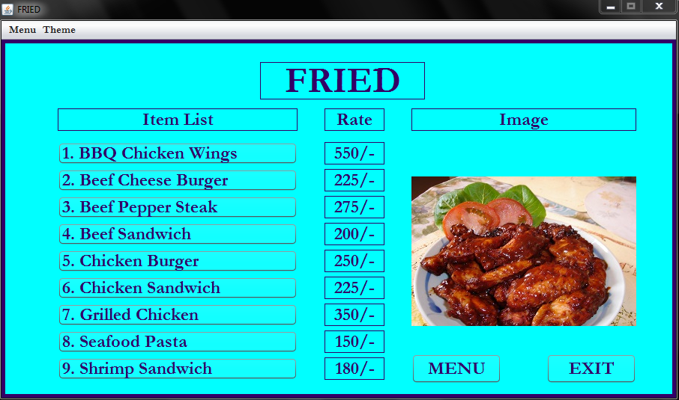

**Fig. 4.5.2 Different fried with image1**

Furthermore, while ‘Chicken Burger’ has been selected.

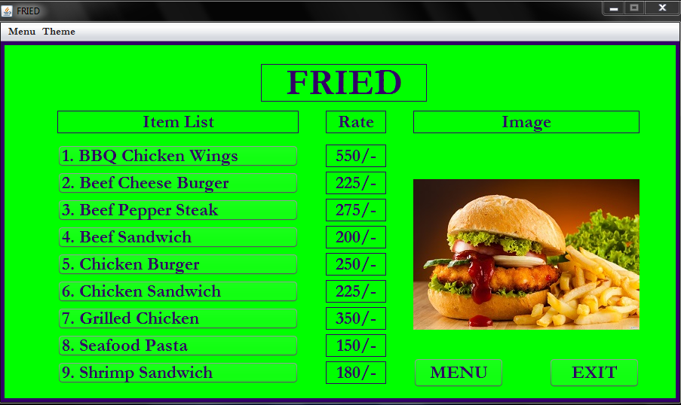

**Fig. 4.5.3 Different fried with image2**

By clicking ‘Grilled Chicken’, this image will appear.

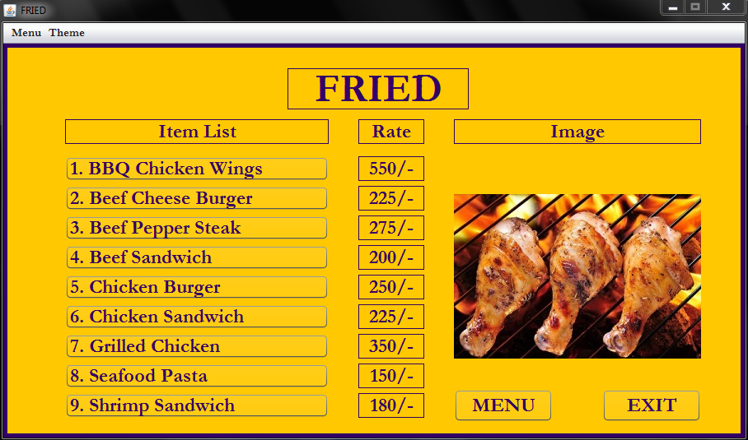

**Fig. 4.5.4 Different fried with image3**

Clicking the “EXIT” button, the user can choose to exit the frame.

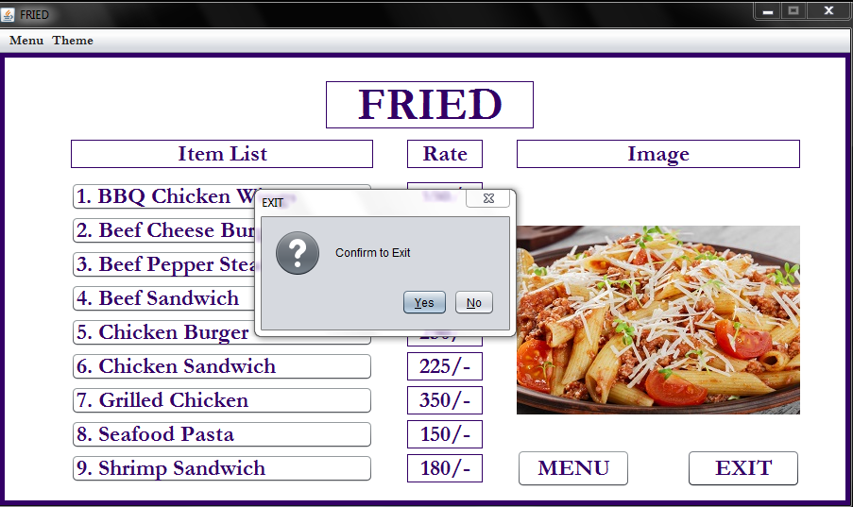

**Fig. 4.5.5 Exit in fried frame**

**4.6 Pizza:** When “PIZZA” button is clicked, the following frame is appeared.

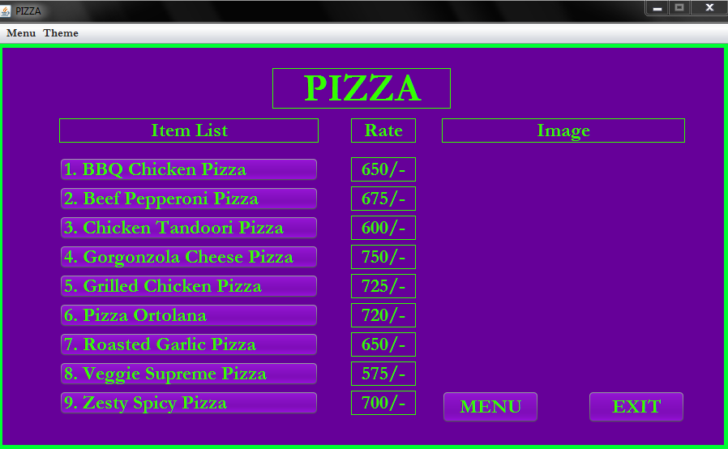

**Fig. 4.6.1 Pizza with default theme**

Another theme with a stylish design.

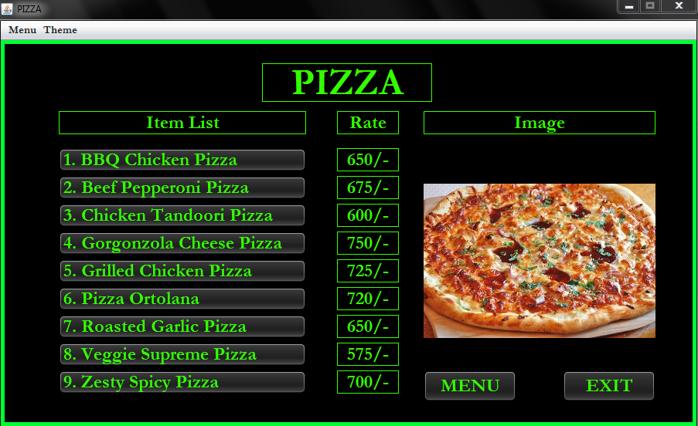

**Fig. 4.6.2 Different pizza with image1**

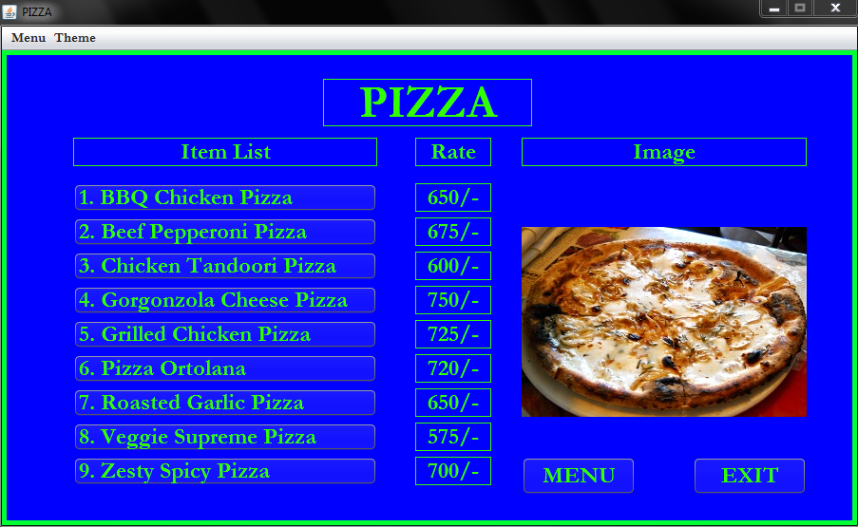

**Fig. 4.6.3 Different pizza with image2**

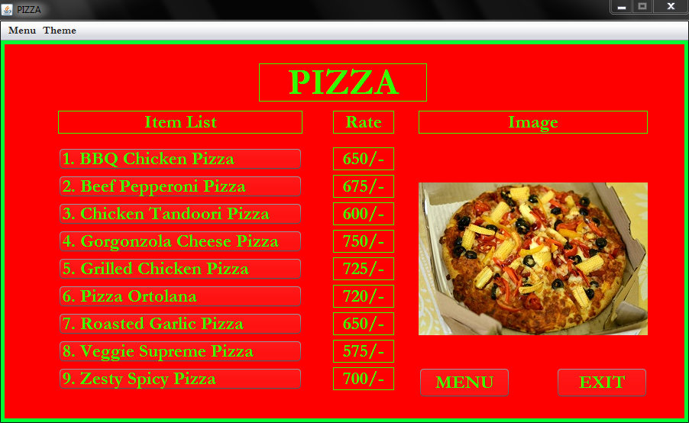

**Fig. 4.6.4 Different pizza with image3**

Clicking the “EXIT” button, the user can choose to exit the frame.

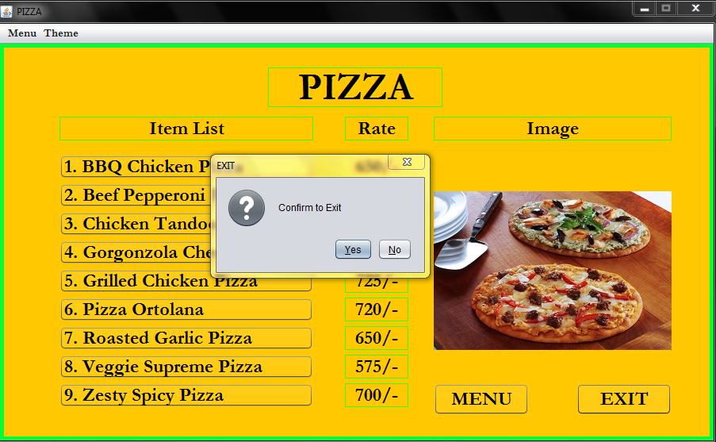

**Fig. 4.6.5 Exit in pizza frame**

**4.7 Soup:** By clicking the “Drinks” button in “Item List”, this frame will be appeared.

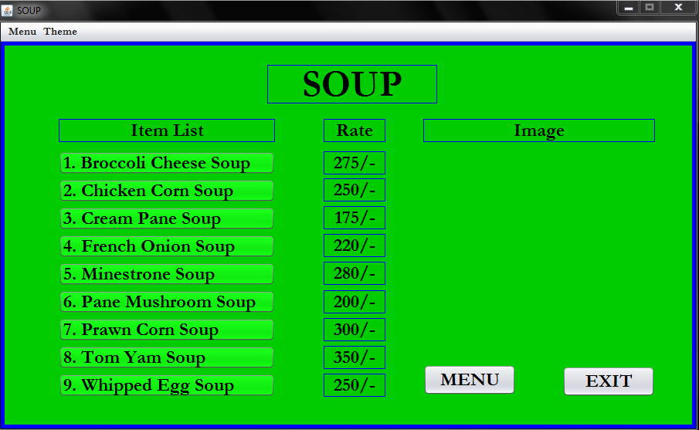

**Fig. 4.7.1 Soup with default theme**

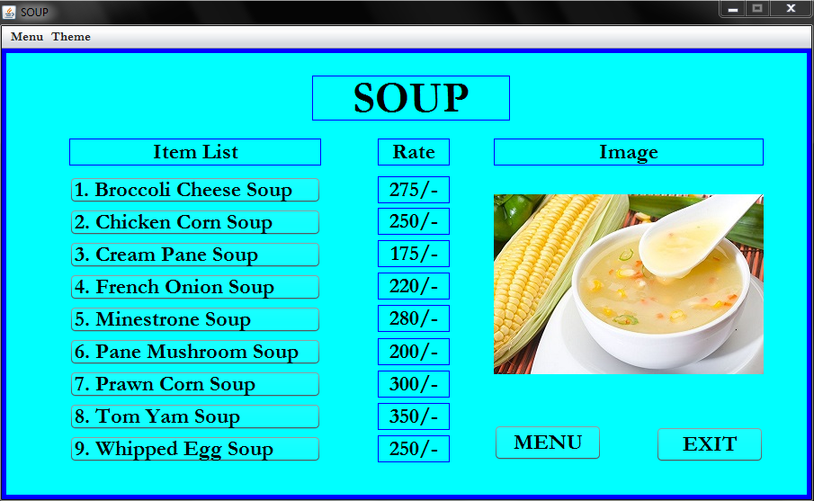

**Fig. 4.7.2 Different soup with image1**

Clicking ‘Cream Pane’ button, the following image will be shown.

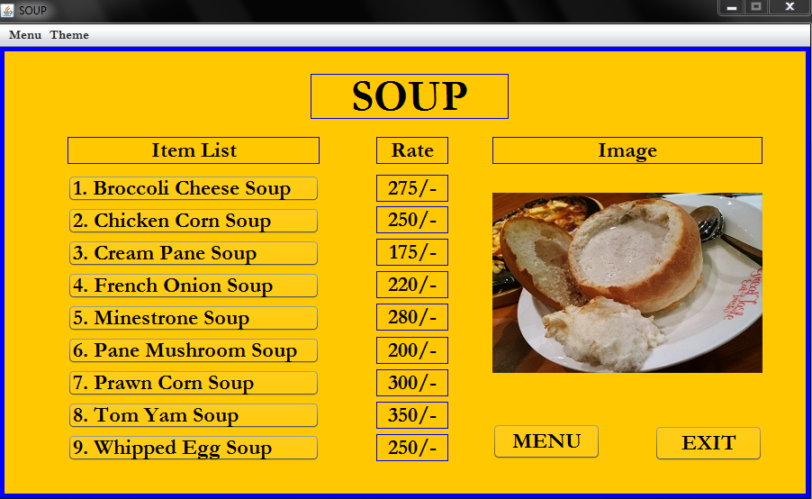

**Fig. 4.7.3 Different soup with image2**

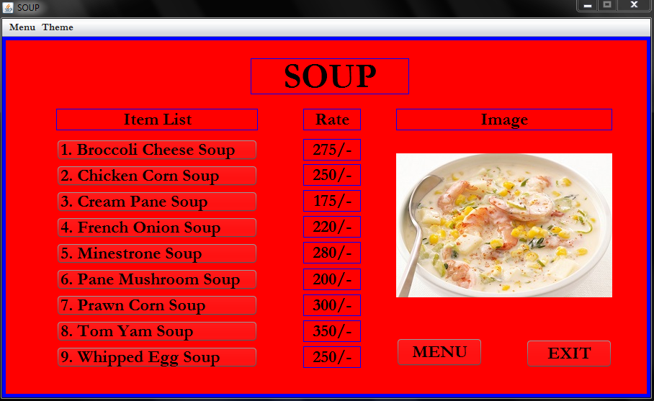

**Fig. 4.7.4 Different soup with image3**

Clicking the “EXIT” button, the user can choose to exit the frame.

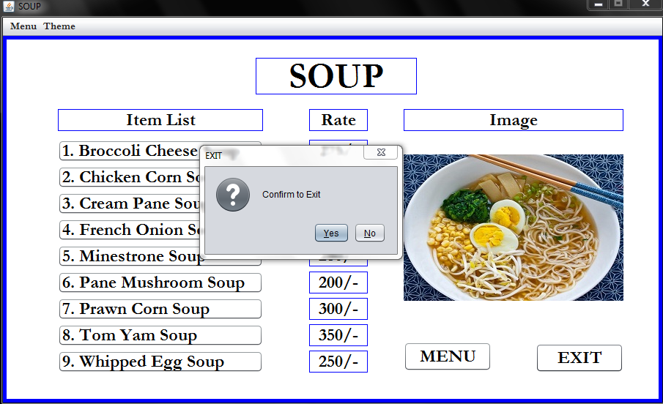

**Fig. 4.7.5 Exit in soup frame**

**4.8 Customer Data:** At “Item List” if “ORDER” button is selected, the following data entry comes.

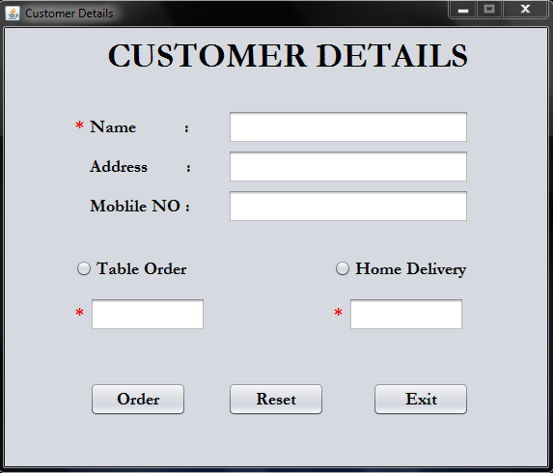

**Fig. 4.8.1 Customer Data with default theme**

This frame will show an Error message, if any of required field remains empty.

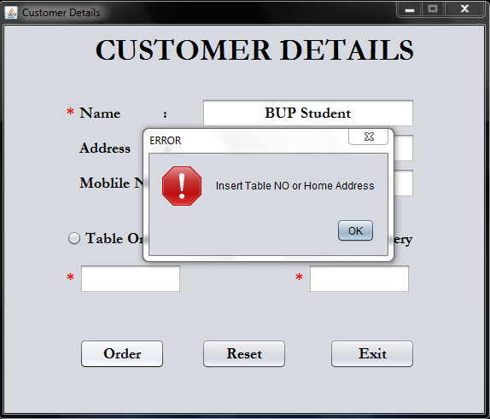

**Fig. 4.8.2 Customer Data with invalid input**

At least, by filling the textfield “Name” and “Table Order” or “Home Delivery”, it is considered as a valid data entry.

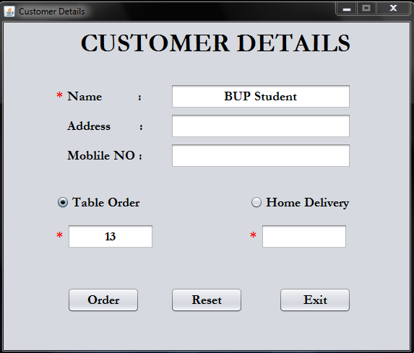

**Fig. 4.8.3 Customer Data with valid input**

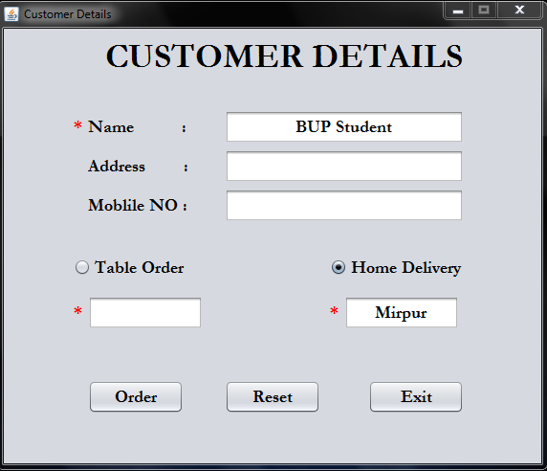

**Fig. 4.8.4 Customer Data with another valid input**

**4.9 Order:** This order frame will come only after filling the required field in the previous frame. Then the user can make an order to thy system.

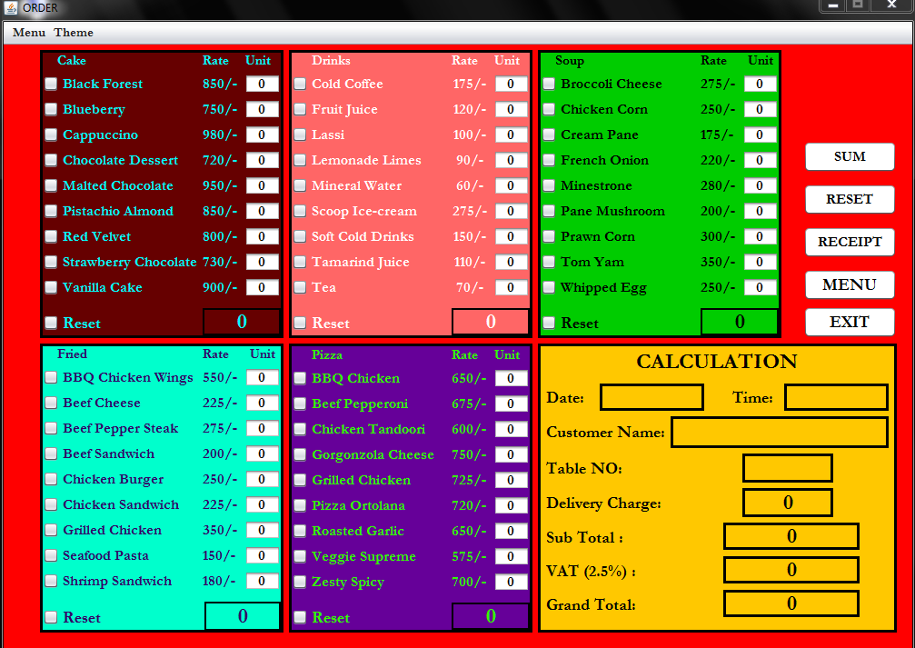

**Fig. 4.9.1 Order with default theme**

A user can choose any of this items to make an order by giving its quantity.

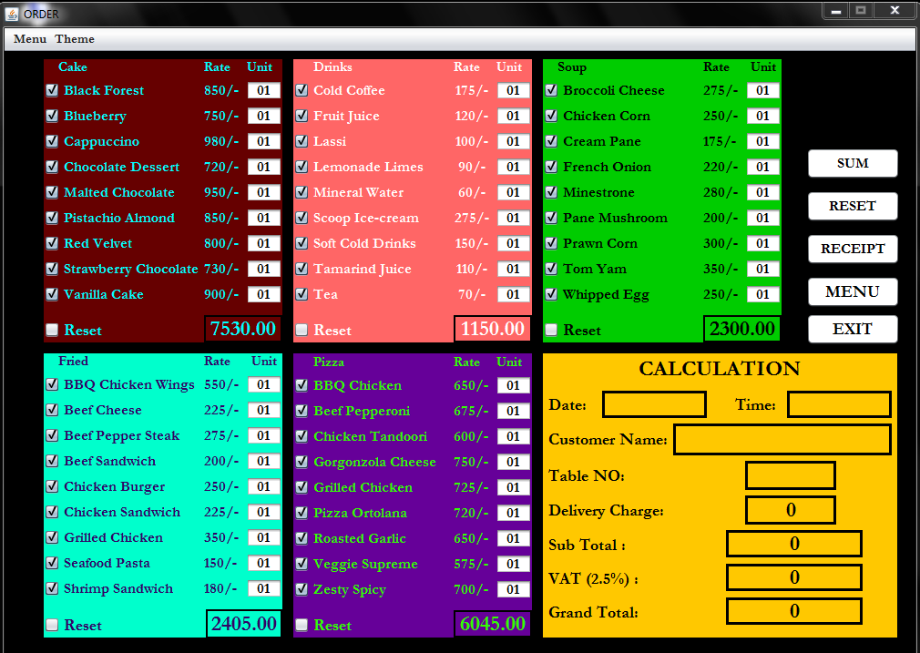

**Fig. 4.9.2 Proper selection of food item** 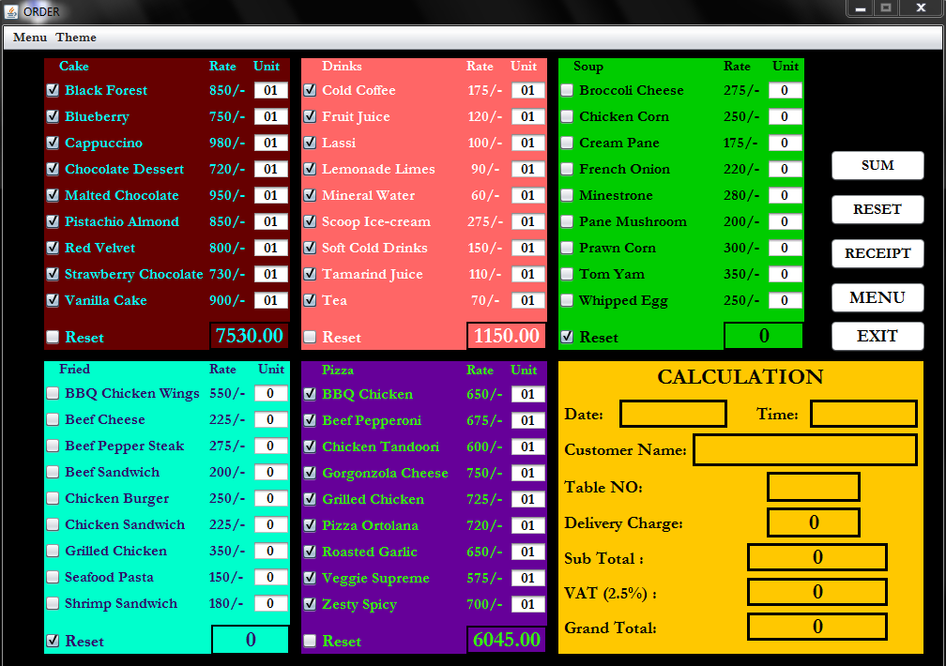

**Fig. 4.9.3 Particular order can be reset**

The entire data can be reset by clicking the button “RESET”. When a user in confirm to see the calculation, make a press to the button “SUM”. Therefore, the user will be able to see the total cost with estimated date and time.

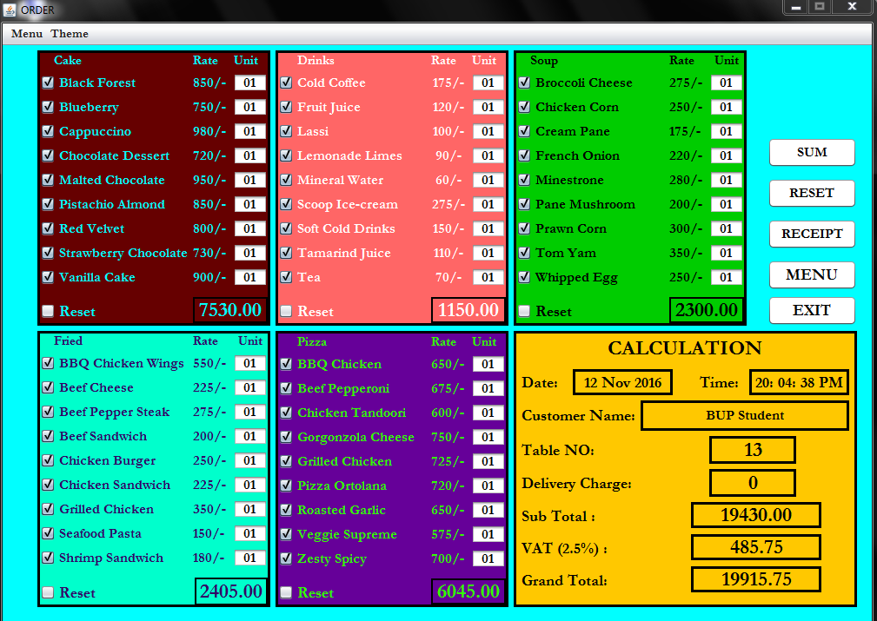

**Fig. 4.9.4 Performing the order calculation**

**4.10 Payment:**

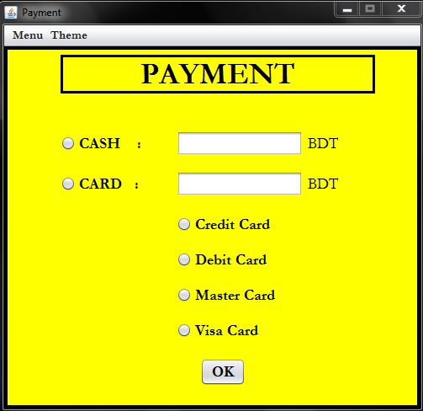

**Fig. 4.10.1 Payment with default theme**

The Payment frame will be appeared while the “RECEIPT” button is clicked.

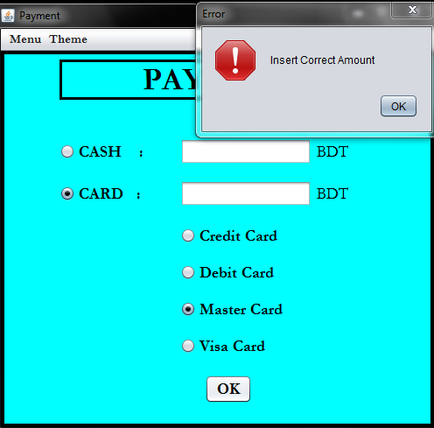

**Fig. 4.10.2 Invalid amount**

If the bill is not paid in a correct method, the above Error message will be shown to the user. Only after paying a valid amount of bill, the user will be able to have receipt.

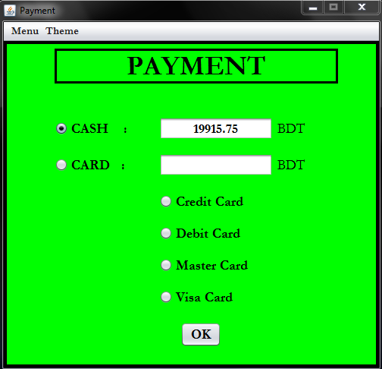

**Fig. 4.10.3 A valid payment method**

**4.11 Receipt:**

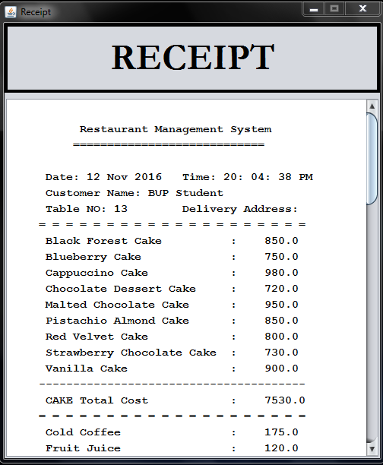

**Fig. 4.11.1 Copy of receipt**

Then, pressing “OK” button in the previous frame, the user will get the receipt.

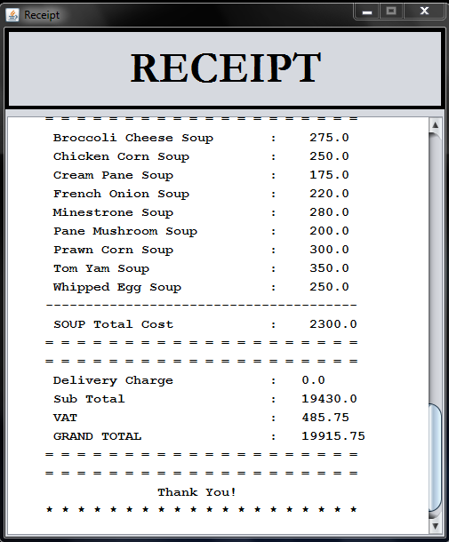

**Fig. 4.11.2 Receipt with order and bill**

**CHAPTER 5**

**CONCLUSION**

**5.1 Conclusion:**

The project “Restaurant Management System” has been completed within shortest possible time. A lot of featured were supposed to be added in this project. But due to the limitation of time, it was hardly possible to complete the entire project with all the expected features. But we have tried our best to make this project beyond limitations. Still now, many more things are needed to add in this project to make it more professional.

This project might be online based where people can use this system in websites. Through signup the user can be a registered member of the website. Now, the user is able to get the updated menu via e-mail id. They can browse the website for ordering the menu online. Even they may pay their cash through online paying system. In the website, this system will verify the user’s online card to get the payment.

Moreover, there might be added a feature for the restaurant manager, staff and cook which will be known as “Admin Panel”. In this section, the restaurant manager can take an overview of the entire monitoring and management system of a restaurant. In the online base of this system, the admin panel can update the list of working staff and cook. In this way, the system will be conducted in online basis where the stronger security and privacy of a restaurant will be ensured. According to the digital security system of Bangladesh, this system might be verified by the legal authorities to ensure privacy and security.

Database, is another important term in this project that can be added to store data of both a user and restaurant admin panel. As this system is going to be online base, it is more important segment to store data with enough security and privacy. Since the user may pay their bill through online, proper security of money should be ensured. In the database management system, the monthly salary of each staff and cook might be added. Besides, it is more important to provide the user an updated list of food menu and respective price with specific images of each item. Thousands of data is to be stored in this system.

Above all, this project “The Restaurant Management System” has yet been completed with the most accurate calculation and stylish theme. In this project, total 45 items have been included to the system and many more features have been shown here which are the initiative from professional aspects. As still now, this project is being developed the complete software might be available in the future.

**Reference**

* <https://sourceforge.net/directory/os:windows/?q=restaurant%20management%20system> on 23 October, 2016.
* <https://sourceforge.net/projects/restmanagement/> on 24 October, 2016.
* <https://codecreator.org/projects/restaurant-management-system-project/> on 2 November, 2016.
* <https://www.youtube.com/watch?v=QTiAEHzirOk> on 3 November, 2016.
* <https://www.youtube.com/watch?v=Ir76a-iPykQ> on 7 November, 2016.
* <http://stackoverflow.com/questions/17412498/pass-values-entered-in-one-jframes-text-field-as-an-input-parameter-in-other-jf> on 9 November, 2016.
* <https://www.youtube.com/watch?v=gLi65Py9PJM> on 9 November, 2016.
* “Java The Complete Reference” (8th edition) by the author Herbert Schildt.
* “Head First Java” (2nd edition) by the author Kathy Sierra and Bert Bates.

**Appendix**

The code for checking valid or invalid username and password in the “Login” frame.

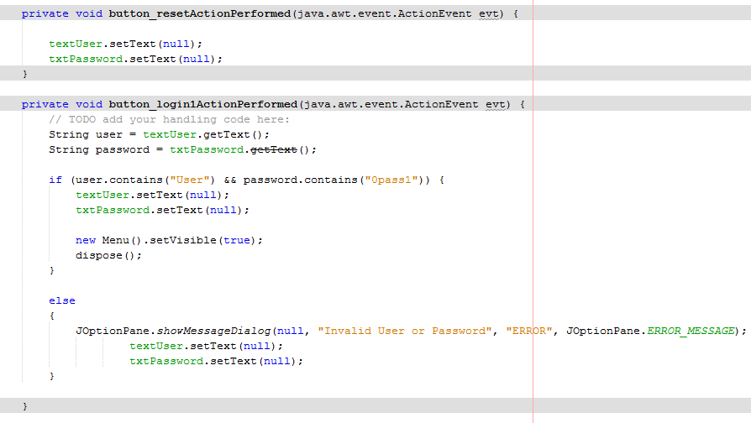

The following code is for “Exit”.

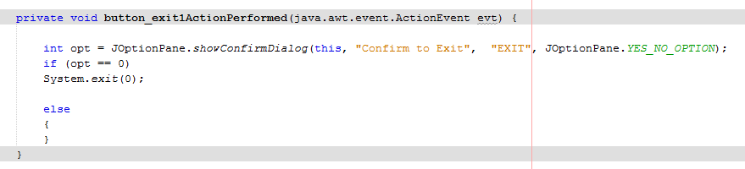

THE END